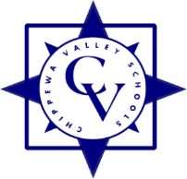

**Chippewa Valley Schools**

**Curriculum Sub-Committee Meeting Minutes**

Date: **Monday, March 3, 2025** Meeting started at: **5:33 pm**

Present: **Denise Aquino, Monica Radyko, Robert Wojtowicz**

Also Present: **Don Brosky, Marina Licari, Ron Roberts**

Additional Present: **Kim Adlam, Sarah Monnier-White, Gabi Castillo (Curricular Leader)**

Brief description of agenda items and discussion

1. Overview of Elementary Reading Series Pilot Process:

* Timeline
* Current Reading Program adopted in 2017 is being phased out by the publisher
* MDE Grant will fund new adoption
* Two Programs selected by teachers to pilot
* 49 teachers representing every grade at all elementary schools have piloted
* Pilot teachers will recommend program for adoption for 2025-2026 school year
* Recommended reading series presented at April K-12 Evaluation Committee meeting
* Motion to adopt at April 7, 2025 Board of Education meeting

1. Questions from Curriculum Sub-Committee

Meeting Adjourned at : **5:54 pm**

Respectfully Submitted,

Donald Brosky