[Chippewa Valley Middle School Volleyball Camp 2025 Registration](https://chippewavalleyschools.ce.eleyo.com/course/944/camps-clinics-and-leagues-2024-25/cv-volleyball-camp)

[Dakota Middle School Volleyball Camp 2025 Registration](https://chippewavalleyschools.ce.eleyo.com/course/1038/camps-clinics-and-leagues-2025-26/dakota-middle-school-volleyball-camp)

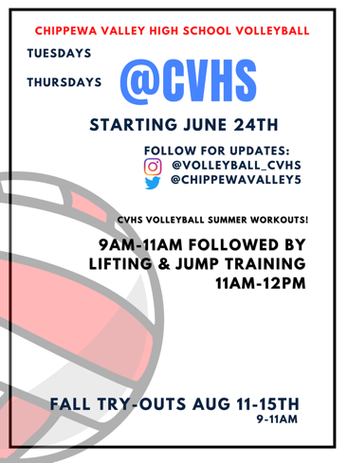

**Wyandot Middle School 2025 Fall Volleyball Tryouts**

Wednesday 9/3/25 (3:00-5:00)

Thursday 9/4/25 (3:00-5:00)

Friday 9/5/25 (3:00-4:30)

*All players MUST have physical to be eligible to tryout. **No Exceptions.**

*Come to tryout’s prepared with gym wear, gym shoes, water bottle and physical.

*Participants should attend all three days of tryouts.

Girls that make the team:

*Practice starts Monday 9/8/25

*Practice will be held Monday-Friday with some exceptions.

*Two games a week will be played.

*Away games, one way transportation will be provided.

Summer volleyball camps can be found at most universities throughout the summer.

Local volleyball clubs like Crank It, Monster, Mi Elite, Legacy also run camps throughout the summer.

**Coach Fredal** – 8th Grade

**Coach Felcyn** – 7th Grade