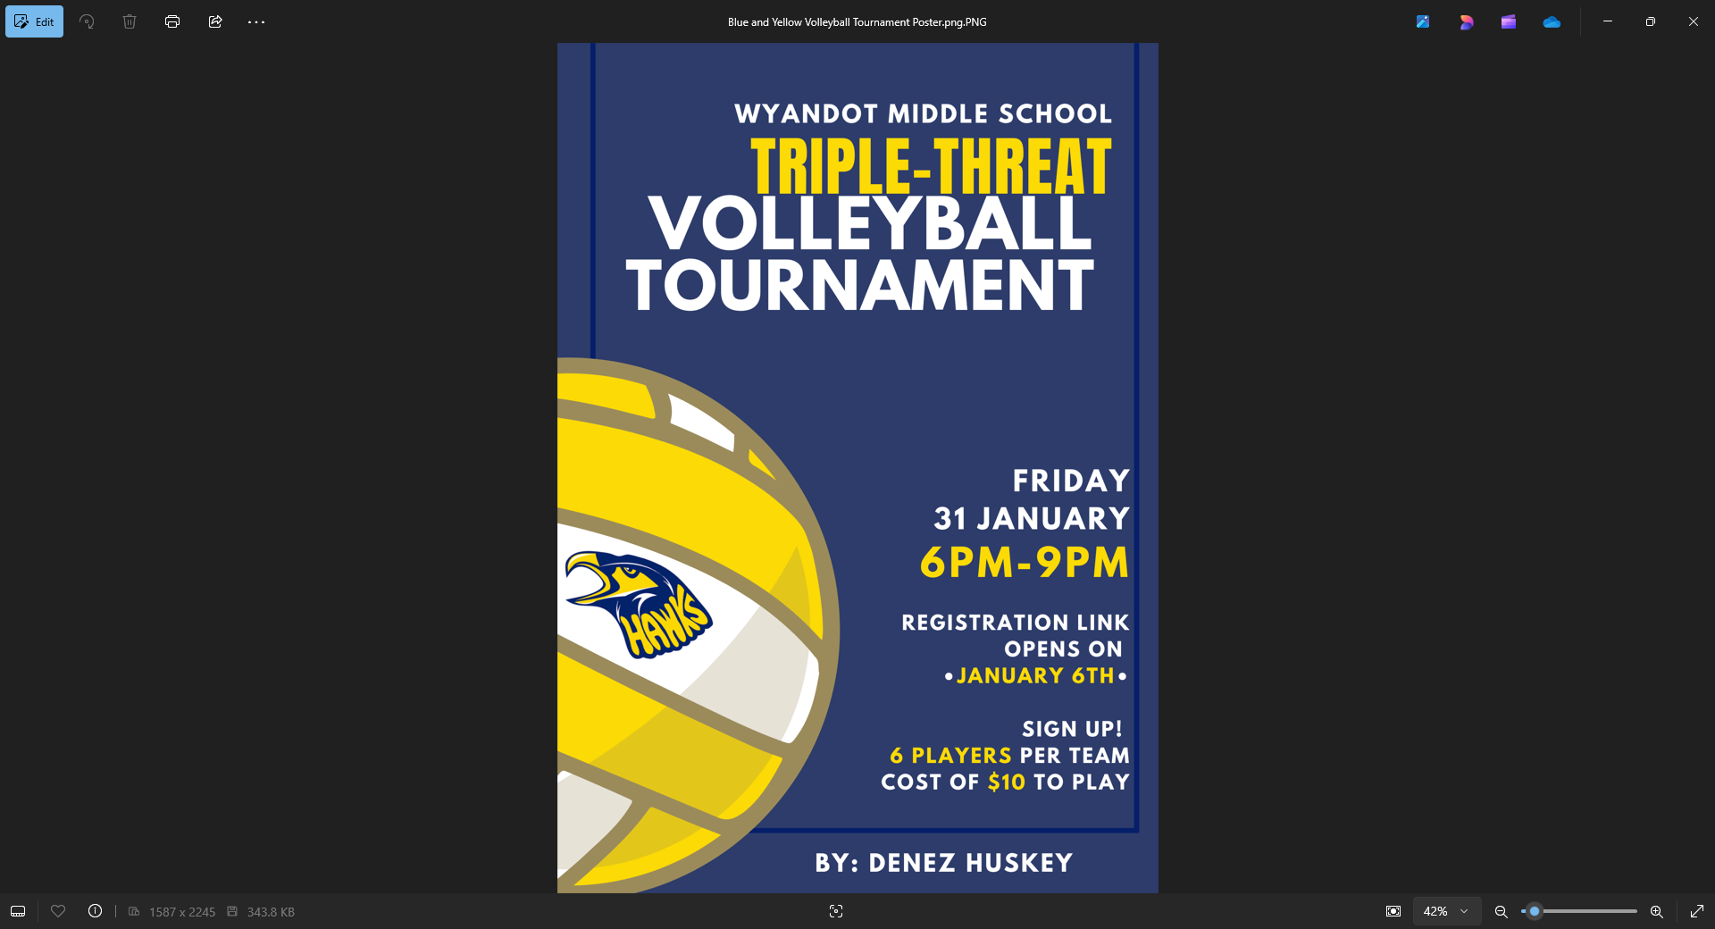
February 6th from 6pm-9pm
Sign up link will open 1-13-26 on your counselor’s Schoology pages.

$10, per person, 6 per team
$1 to come out to watch.

Teachers can be a free 7th player

All $ to the American Cancer Society

